**Overview of SQL Server Data Tools**

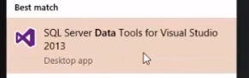

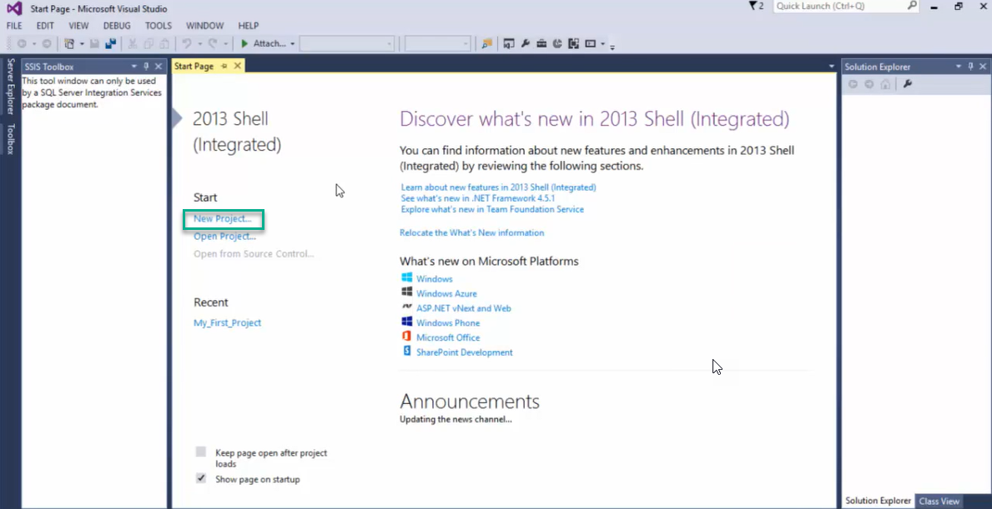

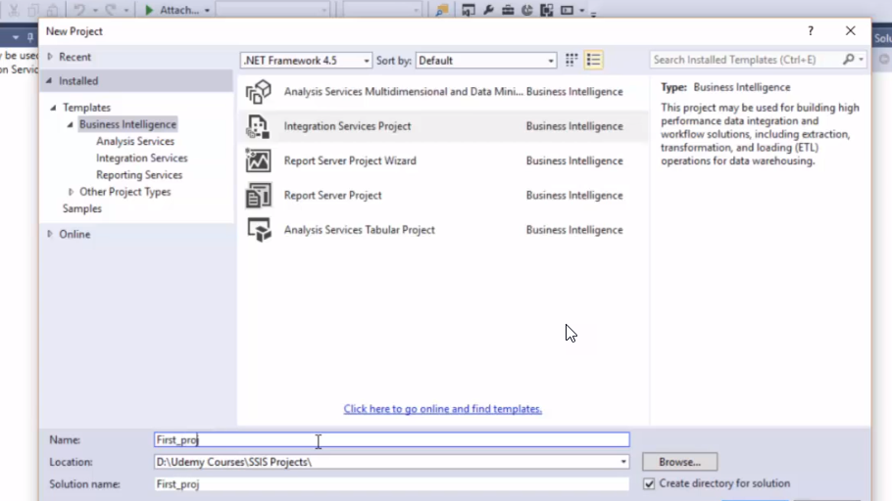

Package.dtsx

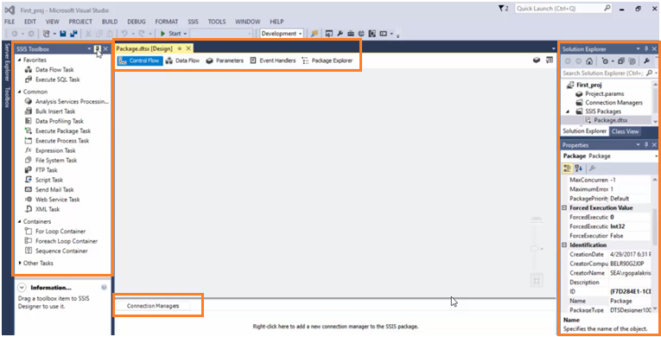

**Control flow** – processes flow from start to finish

**Data Flow** – Data movements

**Connection Manager**  – Connection information of Source and Destination

**Parameters** – Parameters to pass values

**Properties panel** – package properties